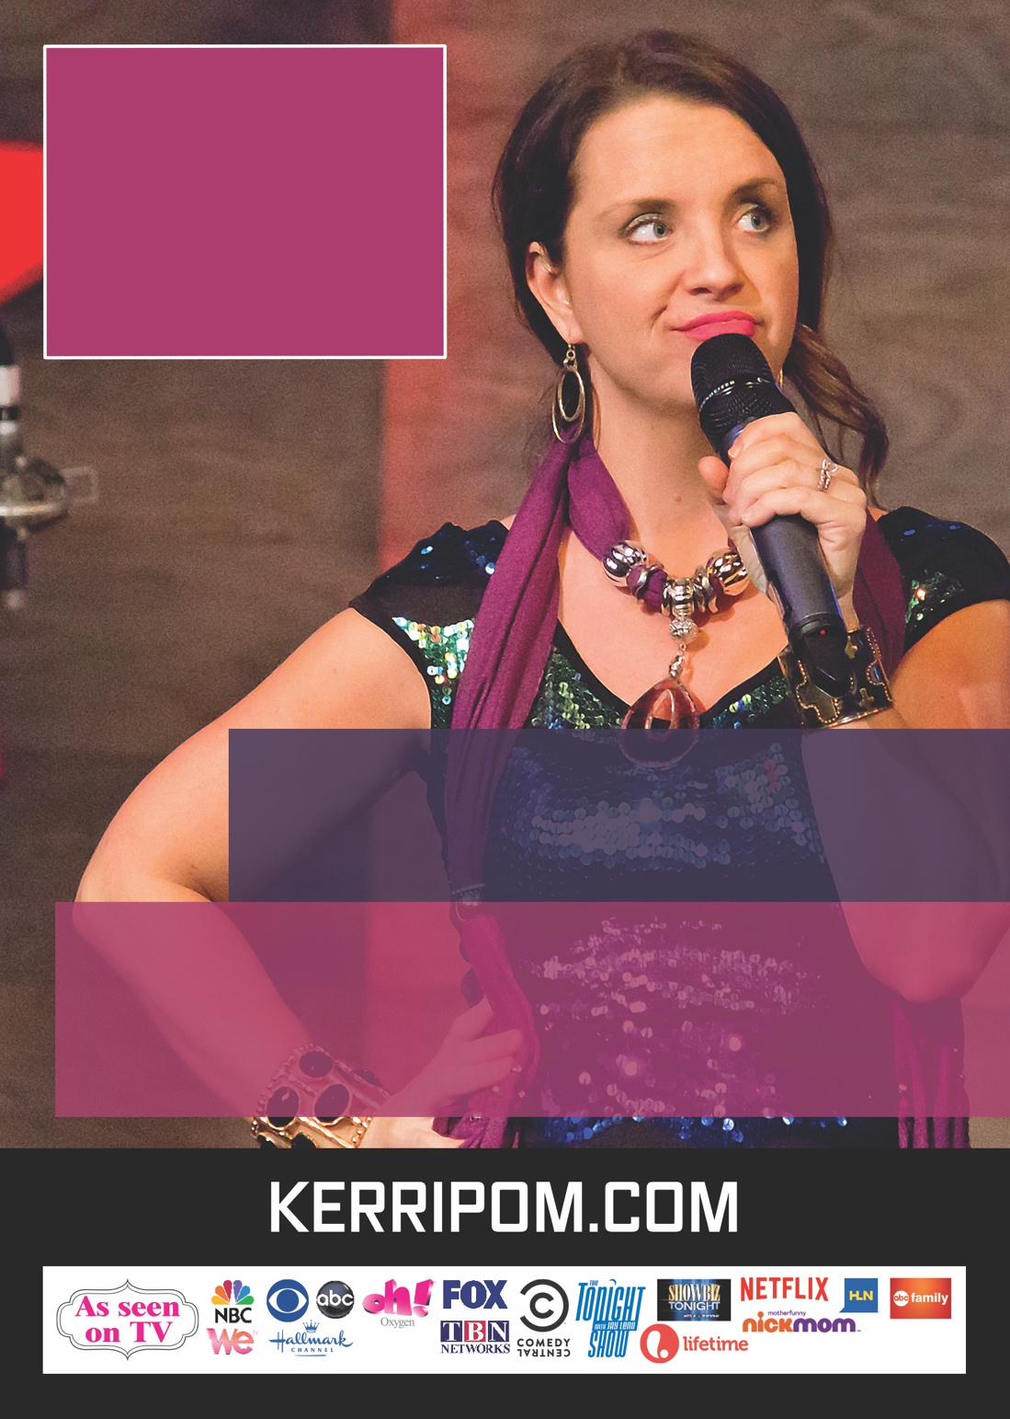

WITH KERRI POMAROLLI

NOVEMBER 9 / 7PM

CORNERSTONE CHURCH

WILSON THEATER

1445 FULTON ST / FRESNO, CA

CLEAN

COMEDY

NIGHT

Type to enter text